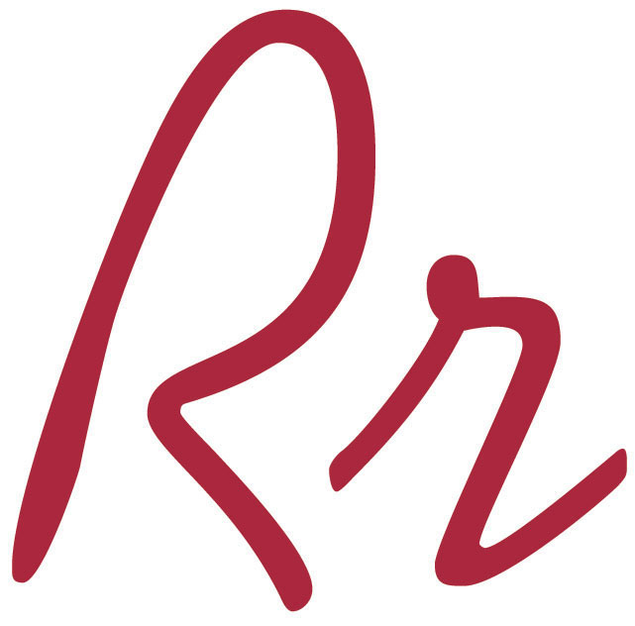
Rocky River High School
20951 Detroit Rd. • Rocky River • Ohio 44116
440.356.6800 • www.rrcs.org
Rob Winton, Principal • Brian Gergely, Assistant Principal
Heath Horton, Assistant Principal • Mark Wagner, Director Athletics & Activities

ROCKY RIVER HIGH SCHOOL

PLAY-SCHOOL REGISTRATION INFORMATION

The play-school program offered by the Child Development class at Rocky River High School is designed to provide an environment where preschool age children can play and interact with their peers, while providing an opportunity to take instruction and direction from people outside of their immediate families. The high school students will provide an atmosphere that fosters social, emotional, cognitive and physical development. This experience allows the high school students to apply the concepts and strategies learned in the classroom, as well as the opportunity to observe behavior patterns, coordination, and other developmental characteristics of preschool age children.

Eligibility of children for enrollment is as follows:
- He/she must be 3, 4, or 5 years old.
- He/she must be in good health.
- He/she must be potty trained.
- He/she must have transportation to and from the high school building.

Please Note: The class size is limited to 15 children.
There is a $20.00 supply fee that must be paid with the registration of your child. This fee will provide art supplies, teaching materials, snacks, and miscellaneous items used during play-school.

Please make check payable to: Rocky River High School.
Please mail the registration form and payment before Wednesday, April 25th, 2018 to:
Rocky River High School
20951 Detroit Road
Rocky River, OH 44116
* Attention Kristen Kalinowski *
You will receive an e-mail confirming your registration that will also include drop off and pick up instructions.

Play school meets four days each week for a total of 3 weeks. We encourage your child to attend every day but if you have scheduling conflicts they are permitted to attend when it fits your schedule.

The following are the dates and times that Play-School will be in session:
Week #1 May 7, 8, 10,11 11:00am – 12:15pm
Week #2 May 14,15,17,18 11:00am – 12:15pm
Week #3 May 21,22,24,25 11:00am – 12:15pm

We are looking forward to meeting your child soon!
Sincerely,
Kristen Kalinowski
Family and Consumer Sciences Teacher
Rocky River High School
kalinowski.kristen@rrcs.org

