January 24, 2014
This Week In Social Group

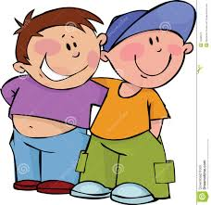

Today we continued our focus on friendship. Specifically we talked about how to be the type of person that people want to be friends with, what friends do for each other, and we got into how to go about making those friends.
What type of person do people want to be friends with? The first thing we talked about was being pleasant. This doesn’t mean that we never get upset, but is part of why it’s so important to control our emotions and stay out of “the red” (remember the thermometer?). If we are sulky or angry a lot of the time, other kids won’t find us very nice to be around. Sometimes we can get so caught up with our own feelings that we forget how we appear to others. We do need to be mindful of body language in this case. One boy even said, “I’ve done every one of those things” when we gave some examples. Some of the boys also mentioned “funny” and “nice” as traits they like in other kids.

We then talked about what friends do for each other. When I initially asked the boys for ideas of things that friends do, no one could think of any examples. We then watched a short video that talked about this and gave some ideas. I listed those things on the board and then after the video the boys were able to think of some more and add to our list. Here’s our list of what friends do for each other:

- comfort each other, or cheer you up
- stand up for each other
- share
- compliment each other
- ask you to play
- take turns and sometimes do what the other person wants

We did then talk about why each of these things is so important. We want other people to do these things for us, but sometimes we forget to do them for others.
Lastly, we talked about steps to take to make a friend. This one really can take people out of their comfort zones. Two out of three boys said that they would like to play with friends outside of school. Two of the boys were also excited to talk about playing together outside of school. They even said they wanted to exchange phone numbers later on!
It was a good introduction into making and keeping friendships, and for the most part, they seem excited to be getting into this!

