Volleyball Unit
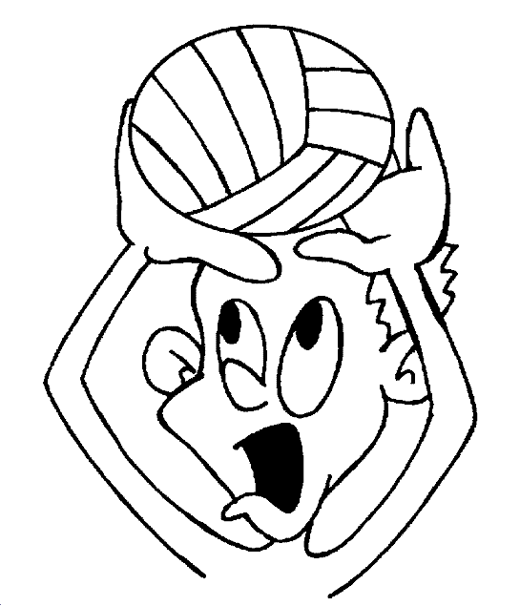

Set up
3 stands and two nets: Please take nets down and put stands against the wall at the end of the day. Two stands have wheels and one must be rolled because a wheel is missing
Remind student - do not kick the balls – it will destroy them
Please make sure all equipment is back in the office and the office is locked at the end of the day
Stretches and Strength Exercises ( Each Day )
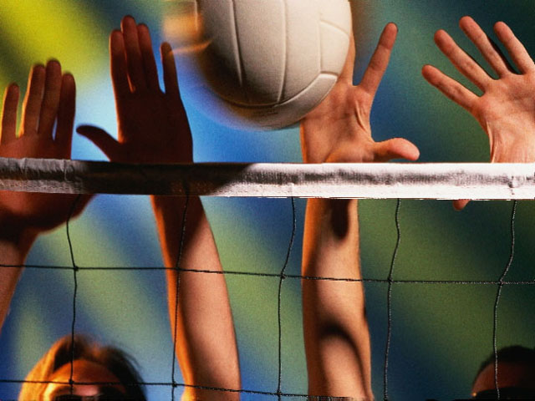

Day I Vertical jump and Bump
Warm up Vertical Net Jump
Two lines on basketball end line – one student from each side vertical jump at net go back and round the cone then jump in 2 area and repeat down the net. At the end of the 2nd net, run around the end cone and return up the sideline into line. Each student should have a least 3 turns. Next person goes when first person gets to the first cone

6 5 4 6 5 4
3 2 1 3 2 1

1 2 3 1 2 3
4 5 6 4 5 6
Next player leaves when the player in front of them gets to the first cone
Do not touch the net!!

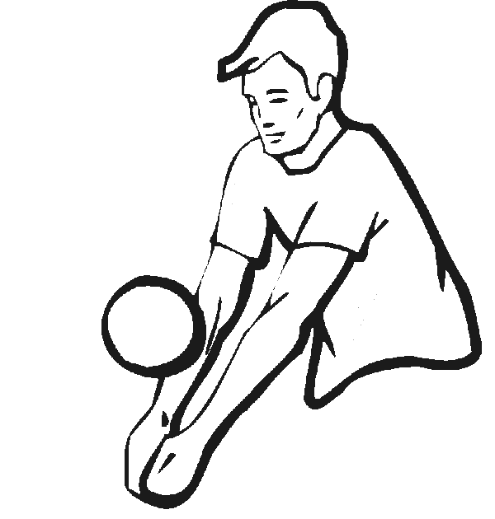

Skill 1 Bump
Air drill using proper technique
Knees shoulder width / knees bent / hands together / elbows together to make an area to contact the ball between wrist and elbow / use legs to move the ball do not swing arms
Partner standing behind the number across toss the ball in a rainbow fashion to your partner who will bump the ball back -catch the ball repeat 5 times then switch with your partner / Demo teacher and one student
Keys: Good technique and control / if you can’t control the ball you need to adjust what you are doing
Add: toss bump – bump – bump catch / trying to control the ball with 3 straight bumps and a catch
Add: How many times can you and your partner keep the ball alive

6 5 4 6 5 4
3 2 1 3 2 1

1 2 3 1 2 3
4 5 6 4 5 6

Toss Bump to partner same side of the net
Skill 2 Set
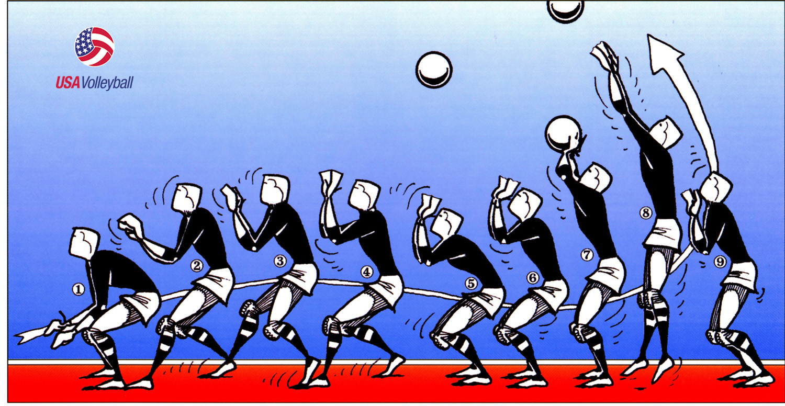

Warm up vertical jump see day 1

Show student proper hand position / triangle window using finger pads – teach absorb and release with fingers hands and arms
Drill one student standing and one on back: Drop the ball at students command and set the ball back up- standing student catches the ball after 5 tries switch places. Work on proper set technique with hands and arms
Drill 2 Back to numbers on the floor work on toss set catch - the toss must be high to allow the student to work on the set
Drill 3 work on combination of set and bump / toss bump set catch

6 5 4 6 5 4
3 2 1 3 2 1

1 2 3 1 2 3
4 5 6 4 5 6

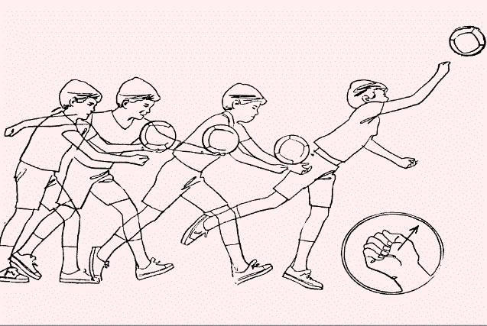

Skill 3 Serve

Drill one on the same side serve to partner
Keys hold ball holding hand waist high / Do not move this hand during serve / back hand strike ball in a forward motion / serve on same side of the net to a partner higher than the net with control
Add: serve bump catch with a partner (Then with 5th grade serve bump set catch)
Drill 2 Server over net
Students behind red line serve over the net – ½ class on one side and ½ on the other side
Partner should be directly across the net

6 5 4 6 5 4
3 2 1 3 2 1

1 2 3 1 2 3
4 5 6 4 5 6

Skill 4 Bump and Set over Net
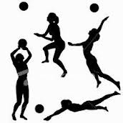

Drill 1 ½ class on the net with a partner try to return with a bump ( then with 4th and 5th grade add serve bump bump catch and serve bump set catch)
Other ½ of class work on back line working on same skills away from the net then switch every 10 min / in between switches - demo students who are following direction and showing good skill

6 5 4 6 5 4
3 2 1 3 2 1

1 2 3 1 2 3
4 5 6 4 5 6

Final Game
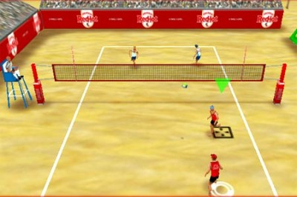

Six on each side / Serve from the back rt corner (underhand serve) / ball cannot go outside of boundary
You must return within 3 hits / the same person cannot strike the ball twice consecutively / if you fail to return the other team serves again and gets a point / you may serve 3 points then the rotation and serve automatically goes to the other side / if a student does not get the serve over the net the get a second try – if the second try fails the rotation and serve goes to the other side / rotate according to numbers 1-2 3-4 ect…… / you do not score points unless you serve / you must win the serve before you can score / we play games to 11/ serves must be returned with a bump and the ball must be handled after that with either a bump or set no one handed strikes
Work on
Ready position / proper technique / control
Discuss:
How to react when you have a disagreement
Replay or make a decision and move on
More play less talk!!!!
Teamwork makes the dream work!!!!!

