**Coffee Talk**

* Goldwood Room, Goldwood Primary School
* 10/12/2017
* 9:30 am

All K-5 parents are welcome!

Books titles include:

* 1- Wonder (by RJ Palacio)
* 2- The Me Me Me Epidemic: A Step by Step Guide to Raising Capable, Grateful Kids in an Over Entitled World (by Amy McCready)

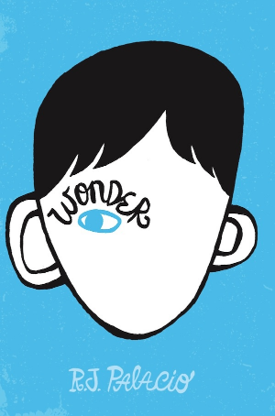                 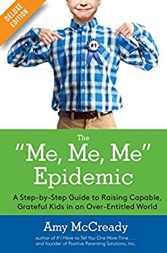

Ms. Peg Liberatore   [440/356-6753](tel:(440)%20356-6753)

Mrs. Melissa Liberatore [440/356-6770](tel:(440)%20356-6770)